**MIS 6308**

**Fall 2017**

**Assignment 2**

**Question 1 (10 points)**

Create the following UML diagrams for DoorDash.

1. Context diagram

**Answer 2a:**

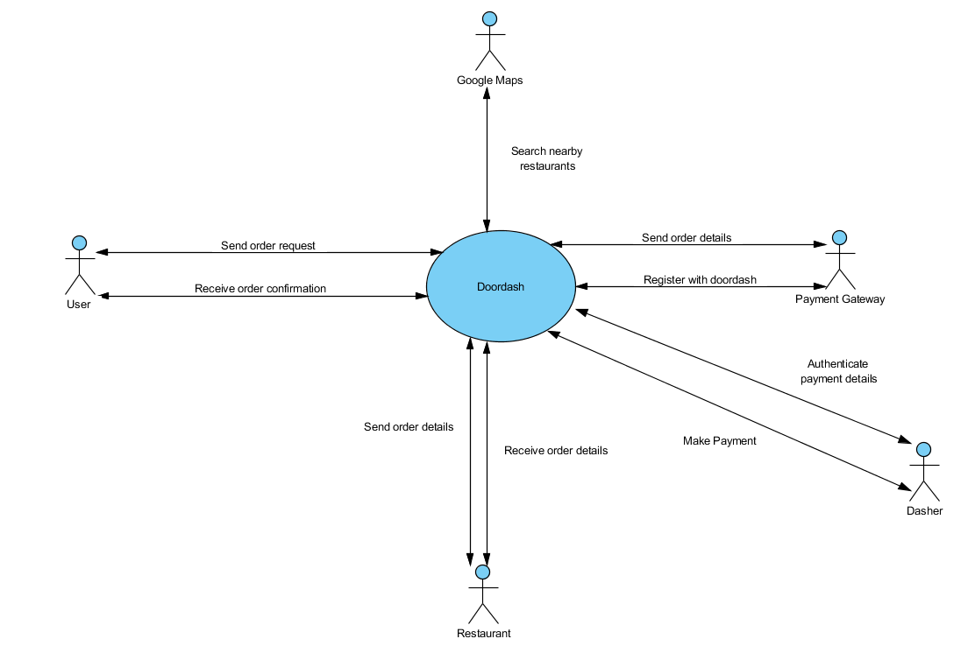

1. Use case diagram

**Answer 2b:**

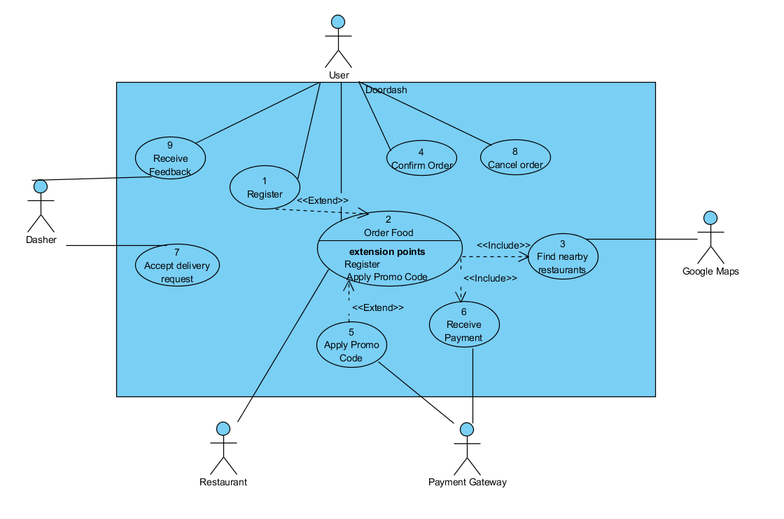

1. Description for the main use case that deals with ‘order food’ in your diagram. Make sure that you underline all data referred in the use case description steps.

**Answer 2c:**

|  |  |
| --- | --- |
| Use Case Name: | Order Food |
| Primary Actor: | User |
| Brief Description: | User orders food from Doordash.com |
| Stakeholders: | User: Wants to order food Dasher: Offers food delivery to user |
| Trigger: | User clicks on “Order Now” button |
| Normal flow of events: | 1. Login using user details 2. Execute Find Nearby Restaurants Use Case 3. Send restaurant details to user 4. Receive user’s order confirmation 5. Execute Receive Payment Use case 6. Send order details to restaurant 7. Receive order confirmation from restaurant 8. Send ride request to dasher 9. Receive dasher confirmation 10. Send dasher details to customer 11. Receive feedback for service |
| Alternate/Exception flow: | 1.a1. If the login fails, redo this step  1.a2. If not a registered user, execute Register use case  6.a1. If user cancels the order, go back to place order  12.a1. If dasher cancels the request, go back to send ride request to dasher |

**Question 2 (5 points)**

Document all underlined date in your response part c of the question 1 using the data dictionary notation discussed in class.

**Answer 2:**

Data Dictionary:

Use Case 2: Order Food

User Details= First Name + Last Name + Phone No + Email Id + Password + User Country + Street Number + Street Name + City + State + Country + User Zip code + Payment Details

Payment: CCNumber + CCName + Expiration + CCV Code

Restaurant Details = {Restaurant Name + Description + Restaurant Type + Logo + Website URL + Phone No + Photo + Street Address + City + State + Country + Zip code + Rating + Number of Ratings + $Ratings + Delivery Hours + Number of Employees}

Order Confirmation = [Yes|No]

Dasher Confirmation = [Yes|No]

Order Details = Restaurant Name + Phone No + Street Address + City + State + Country + Zip code + Order No + {Item Name + Item Details + Quantity + (Additional Instructions)} + Order Amount + Delivery Time

Ride Request = Restaurant Name + Phone No + Street Address + City + State + Country + Zip code + Order No + Delivery Time

Dasher Details = Dasher First Name + Dasher Last Name + Dasher Phone No + Dasher Gender + Dasher Photo + License No + Dasher Rating

Feedback = Review Rating + Review Comments

**Question 3 (5 points)**

Model the data you identified using a class diagram. There is no need to incorporate methods for classes at this stage.

**Answer 3:**

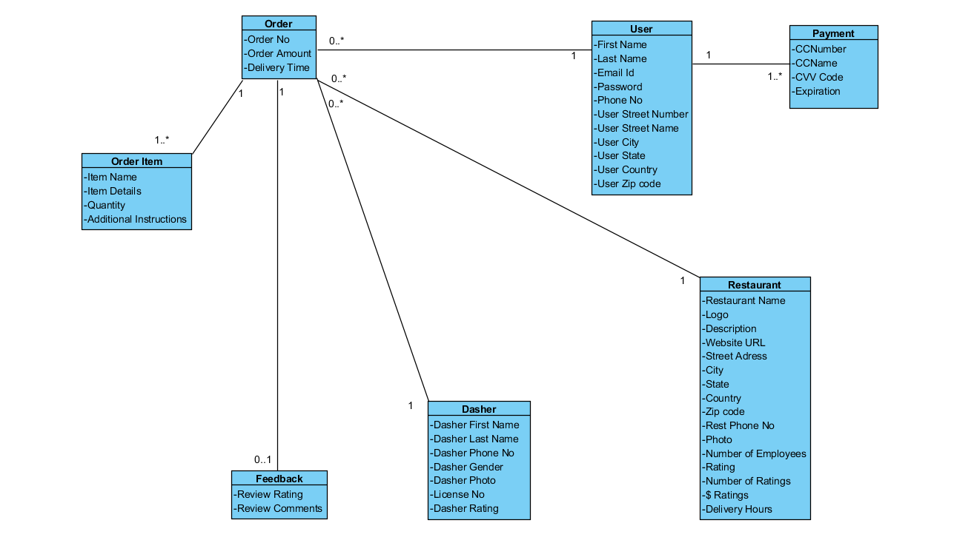

**Question 4 (Extra Credit: 5 points)**

Create a sequence diagram for the order food use case.

**Answer 4:**

